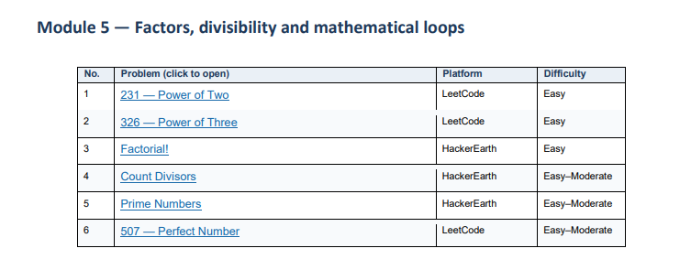

- 231--Power of 10 https://leetcode.com/problems/power-of-two/submissions/2193310100/
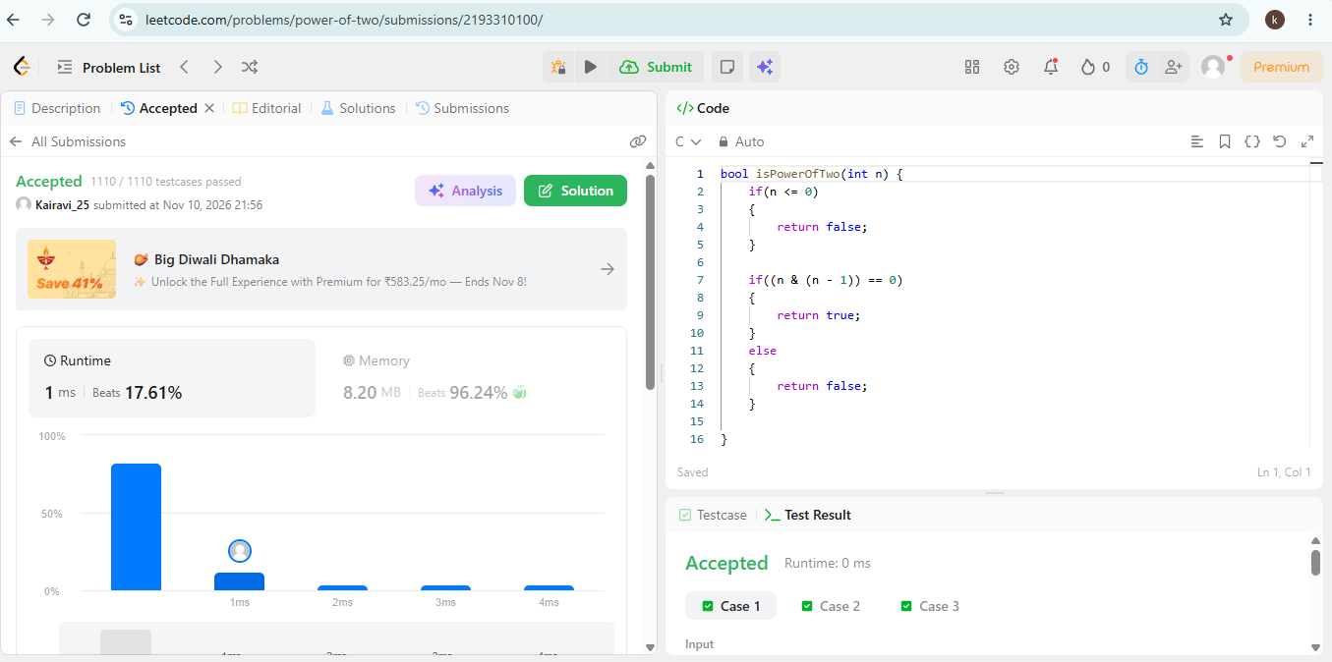

- 326—Power of Three https://leetcode.com/problems/power-of-three/submissions/2193318059/
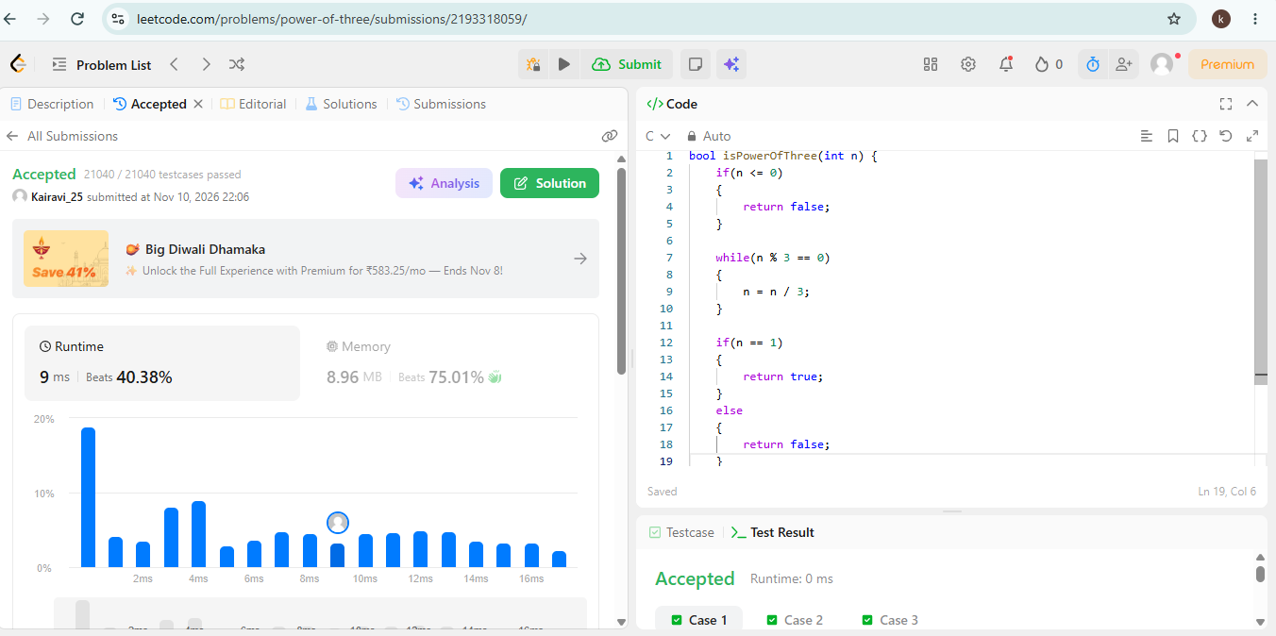

- Factorial! https://www.hackerearth.com/practice/basic-programming/input-output/basics-of-input-output/practice-problems/algorithm/find-factorial/
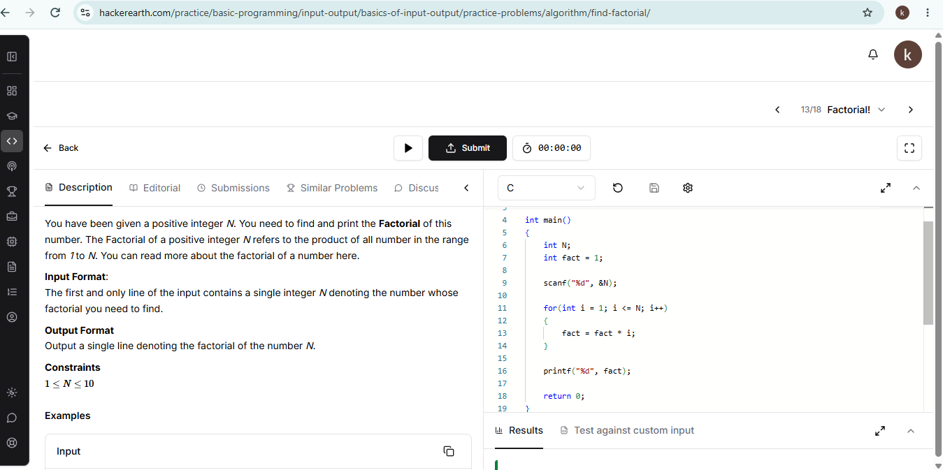
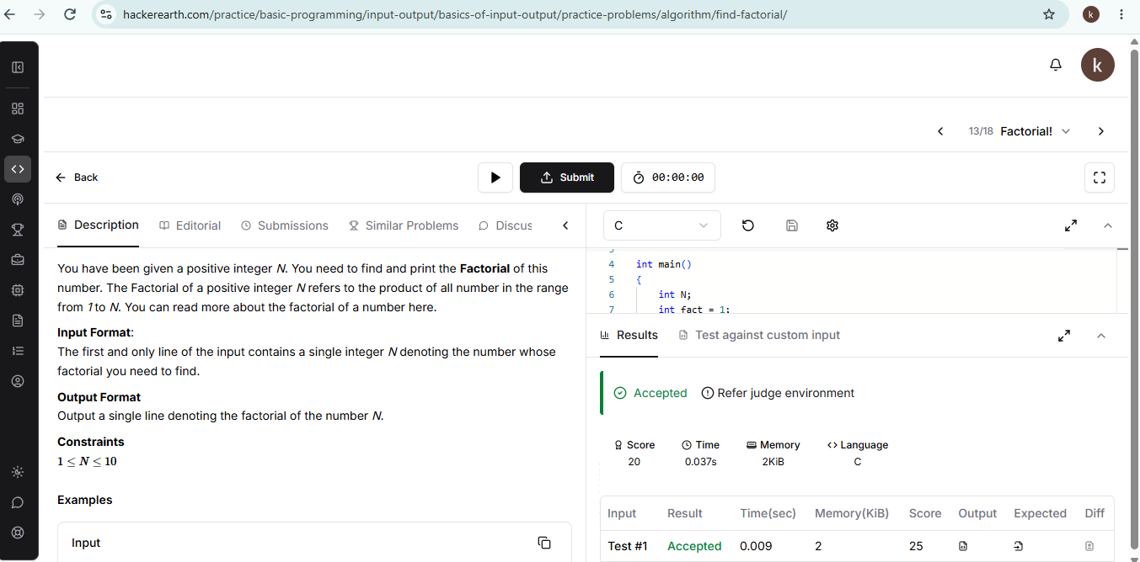

- Count Divisor https://www.hackerearth.com/practice/basic-programming/input-output/basics-of-input-output/practice-problems/algorithm/count-divisors/
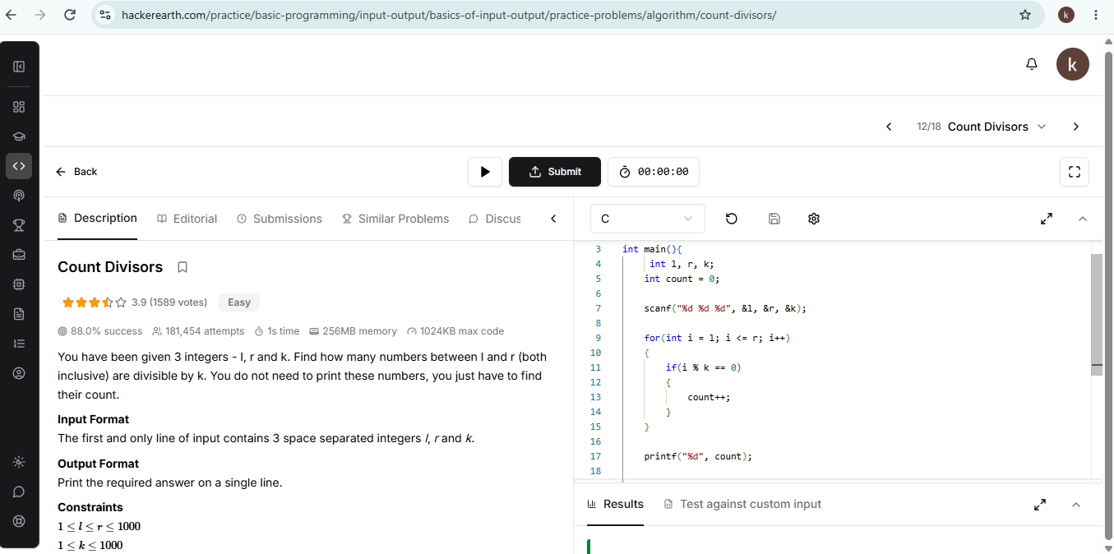
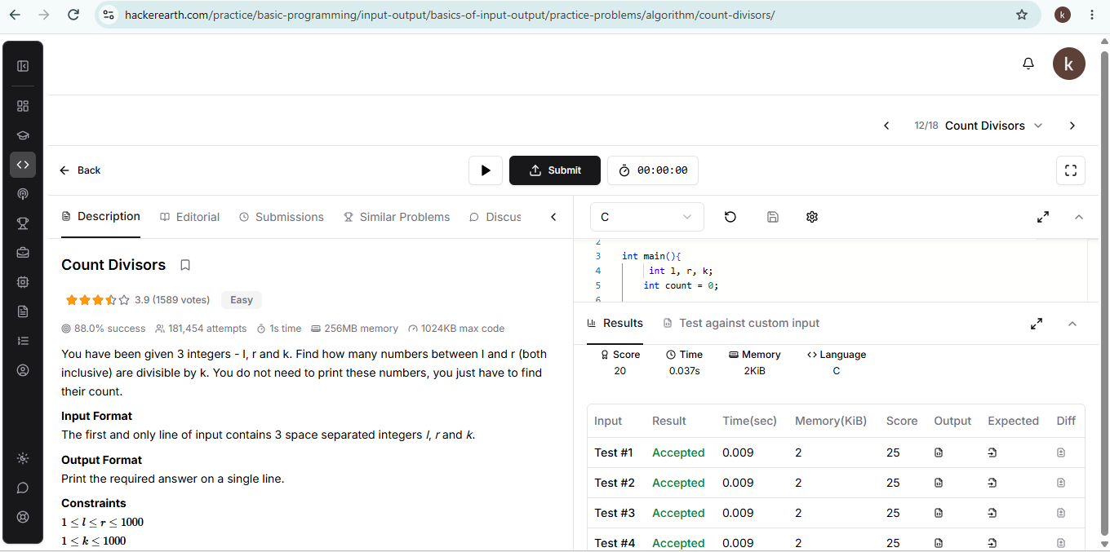

- Prime Numbers https://www.hackerearth.com/problem/algorithm/prime-numbers/
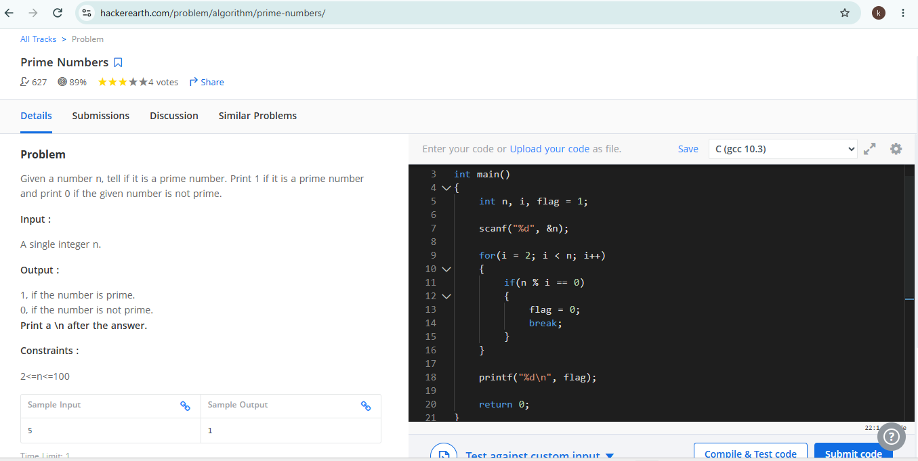
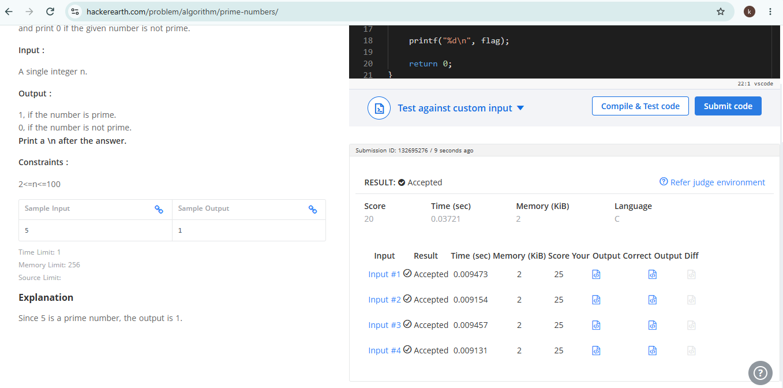

- 507—Perfect Number https://leetcode.com/problems/perfect-number/submissions/2193349383/


